Data Refinement & Transformation with OpenRefine
Pavithran, Lead Engineer
Keywords: Data Refinement, OpenRefine, Transformation
Data Refinement
Data Refining is the process of removing incorrect/inaccurate, inconsistent, incomplete, outdated, insecure, and duplicate data. The data refinement process is most important in all data operations and data analysis, where data must be selected, standardized, categorized, and summarized properly before it is used for advanced analytics.
Data Transformation
The process of changing data from one format towards another is known as data transformation. The tools and procedures used for data transformation are determined by the data's format, complexity, structure, and volume.
Need for Data Refinement and cleaning
The primary goal of Data Cleanup is to detect and remove defects and repetitive results in order to build a trustworthy dataset.
Data Cleaning steps are error identification & error solving. The initial stage in any data cleaning effort is to detect the anomalies.
Any machine learning function must successfully complete the process of data cleaning. The majority of machine learning initiatives spend roughly 80% of their time cleaning up the data.
The Advantages of Data Cleaning
Utilizing descriptive analysis will ultimately enhance productivity levels and allow you to make the best decisions possible.
• The data errors are eliminated.
• Error monitoring and reporting to identify where problems are occurring, making it easier to correct for future applications.
• Using data cleaning technologies will result in more efficient corporate procedures and faster decision-making.
Different ways of transforming data:
- Data extraction and parsing

Data ingestion in modern ELT begins with extracting information from a data source, followed by transferring the data to its destination. The first transformations aim to shape the format and generation of reports.
- Mapping and translation

Both are most fundamental data transformations. The data from one structure to another structure is known as translation.
- Filtering, grouping, and conclusion

Data can be consolidated by removing redundant fields, columns, and records & aggregated or summarized as well. BI systems are capable for this functionality, it may be more convenient to operate the transformations prior to use a reporting tool.
- Clustering and sorting

Data are converted to be logically ordered or to fit a data storage strategy. Creating indexes in relational database management systems, for example, can improve performance or the management of relationships between distinct tables.

Encryption
Private data encryption is required in many businesses, and platforms can execute encryption at different levels.
- Creating models, typecasting, structuring, and renaming
Ultimately, a bundle of transformations can restructure data without altering its content. Casting and converting data types for compatibility, altering dates and timings with offsets and format localization, and renaming schemas for clarity.
Challenges in Data Transformation
- Data transformation can always be costly. The price is determined by the facilities, application, and tools used to process data.
- Data transformation operations can be time-consuming and expensive. It slows down other functions.
Open Refine
- OpenRefine is a totally free and open-source software tool that offers a number of powerful functions to quickly and efficiently clean your data.
- Identify and resolve anomalies in a data set.
- Assist you in dividing data into more specific sections.

Capabilities of OpenRefine
Large-scale data exploration, cleaning, and linking can be done using OpenRefine.
- Data Rearrangement and Filtration
- Data Preparation and Normalization
- Column Reorganization
- Faceting and Clustering
- Tracking Operations
- Exporting Data
- History and Undo/Redo
Faceting and Clustering:
Faceting allows you to quickly view unique values in a column and make edits to those values. (Text Facet, Number Facet, Timeline Facet).

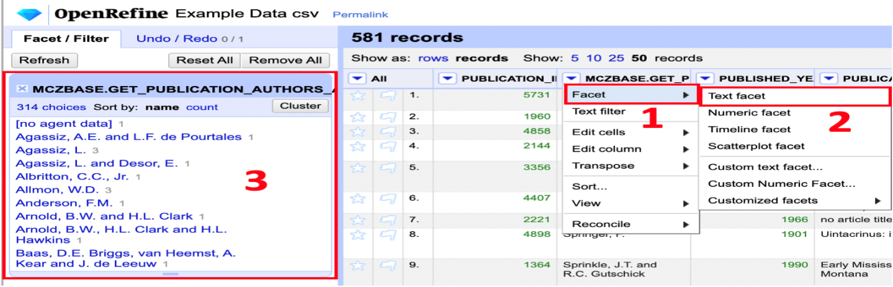

The clustering function can help you to identify inconsistencies in your data, from misspellings to non-standardized value formatting or input error.
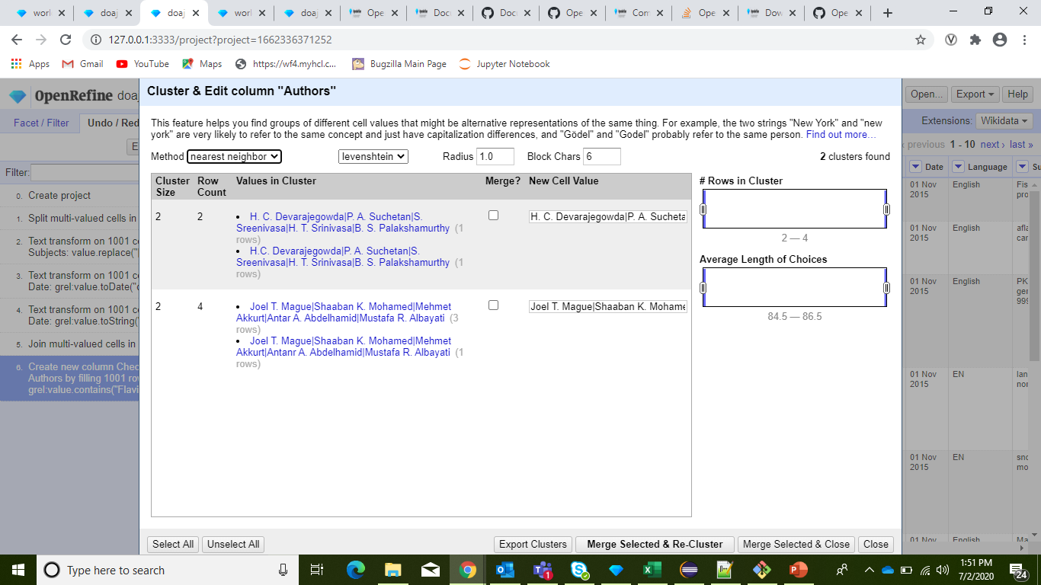

Exporting Data
OpenRefine gives you several options for exporting your data in the format of your choice:
- The most commonly used and widely useful formats are:
- Tab and Comma-separated value
- HTML table
- Excel
- SQL Script

Data Shaping
- Using transpose
- Reorder
- Sorting

Few examples:

Merge two projects based on the key column:
To merge two sets of data, it is critical that each row of data has an unique id, or "key," so when the applications are integrated.

cell.cross('arg1','arg2').cells['arg3'].value[arg4]
arg1 = name of project you are exporting data from
arg2 = name of the key column
arg3 = name of the column you are importing
arg4 = indicate which value to import in the array (if multiple matches for the key)
(recommended to use 0)

Reformat the Date

Remove all Facets and Filters
On the Date column, Edit Cells =>Transform
In Expression box => value.toDate("dd/MM/yyyy") and press "ok"
On the Date column, Edit Column ->Add column based on this column and give column name
In Expression box => value.toString("dd MMMM yyyy")

OpenRefine API:

This is a generic API reference for interacting with OpenRefine's HTTP API.

1.Get X-CSRF
Method: GET
URL: http://127.0.0.1:3333/command/core/get-csrf-token

2. Create a Project
Method: POST
URL: http://127.0.0.1:3333/command/core/create-project-from-upload
Request: Form-data
project-file: Upload the file from the System directory
project-name: Sample Project
format: text/line-based/*sv

3. Apply Operations:
Method: POST
URL: http://127.0.0.1:3333/command/core/apply-operations?project=<project_id>&csrf_token= < csrftoken>=[ { “op”: “core/column-addition”,
“description”: “Text transform on cells in column Date using expression grel:value.toDate()”,
“engineConfig”: {
“facets”: [],
“mode”: “row-based”
},
“newColumnName”:”TestColumn1”,
“columnInsertIndex”:5,
“baseColumnName”:”Country”,
“expression”: “grel:cells[‘Region’].value +’ , ‘ +cells[‘Country’].value”,
“onError”: “set-to-blank”,
“repeat”: false
}
]

4. Export Rows
Method: POST
URL: http://127.0.0.1:3333/command/core/export-rows?project=<project_id> &engine={
“facets”: [],
“mode”: “row-based”
}&format=csv

Other tools like OpenRefine:
- RingLead
- TalendOpenStudio
- DemandTools
- Microsoft Data Quality Services.
- D&B Optimizer
- TIBCO Clarity
- Google Fusion
- Data Ladder
- Drake
- Data Cleaner
- Cloudingo
- Reifier

References:
https://insidebigdata.com/2015/06/15/data-refinement-the-dirty-side-of-data-science/
https://www.einfochips.com/blog/data-cleaning-in-machine-learning-best-practices-and-methods/
https://analyticsindiamag.com/top-8-data-transformation-methods/
https://www.tableau.com/learn/articles/what-is-data-cleaning
https://www.stitchdata.com/resources/data-transformation/
https://docs.openrefine.org/
https://docs.openrefine.org/technical-reference/openrefine-api
https://guides.library.illinois.edu/openrefine/joiningprojects
About the author:

I am Pavithran A, currently working as a Lead Engineer in ERS Research at HCL Technologies. I have total 8 years of experience in different technologies like Java, Python, SQL Server, JavaScript, jQuery, React, Android and PostgreSQL. And also got the chance to work on various domains like AR Augmentation & Data Engineering.

